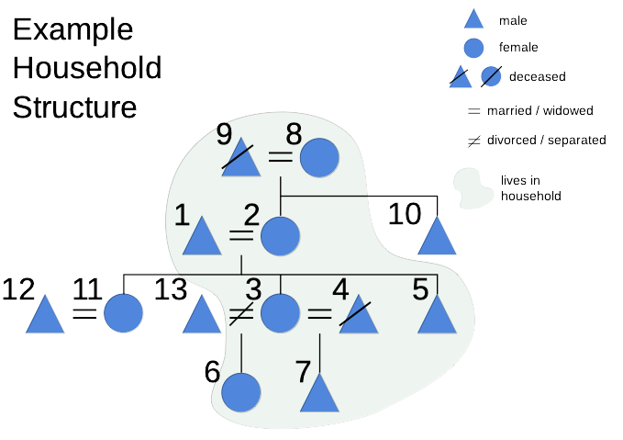
Demographics information for each member::

Number | First Name | Last Name | Age | Sex | Alive | Born | Marital status | Years of Education
1 | Boss | Ding | 44 | M | Y | Here | Married | 5
2 | Betty | Ding | 30 | F | Y | N/A | Married | 7
3 | Dolly | Dong | 21 | F | Y | Here | Widowed | 4
4 | Bobby | Dong | 30 | M | N | Elsewhere | Married | 8
5 | Dylan | Ding | 15 | M | Y | Here | Never
6 | Collet | Effen | 9 | F | Y | Here | never
7 | Donald | Ding | 3 | M | Y | Here | never
8 | Granny | Able | 70 | F | Y | Elsewhere | Widowed | 3
9 | Gramps | Able | 79 | M | N | Elsewhere | Widowed
10 | Manny | Ding | 40 | M | Y | Here
11 | Clary | Numpty | 23 | F | Y | Here
12 | Murry | Numpty | 34 | M | Y | Elsewhere
13 | Garry | Effen | 39 | M | Y | Elsewhere

TODO: Retake all screenshots with updated forms, adjust table above to reflect new changes
Using the example household tree, enter the census details as described in the following steps:

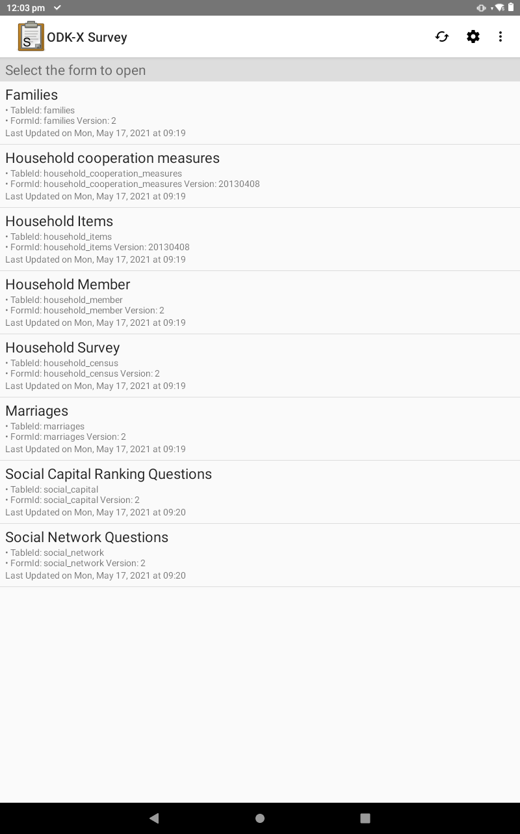

Update screenshot for new form names
After opening the ODK-X Survey application, you will be presented with a screen displaying all the forms present on the device.
For the initial household census, select “Household Survey”

Note regarding other forms:

Household cooperation measures & Household Items are FREELISTING data collection

Household Survey is the main census form

Social Network Questions and
Social Capital Ranking Questions are the SNA data gathering forms

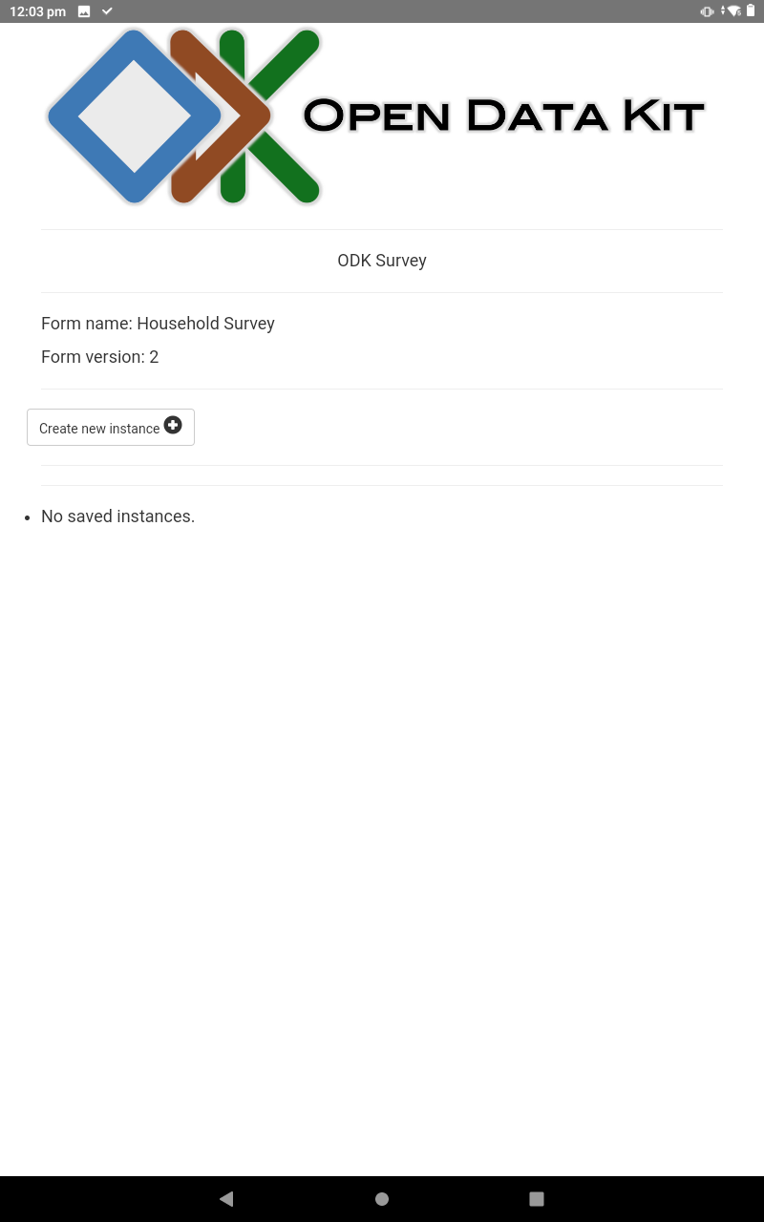

On this screen, every household surveyed will be shown. These are referred to as ‘instances’.
As there are no household instances on the device at the moment, the list is blank.
To begin the survey, create a new instance.
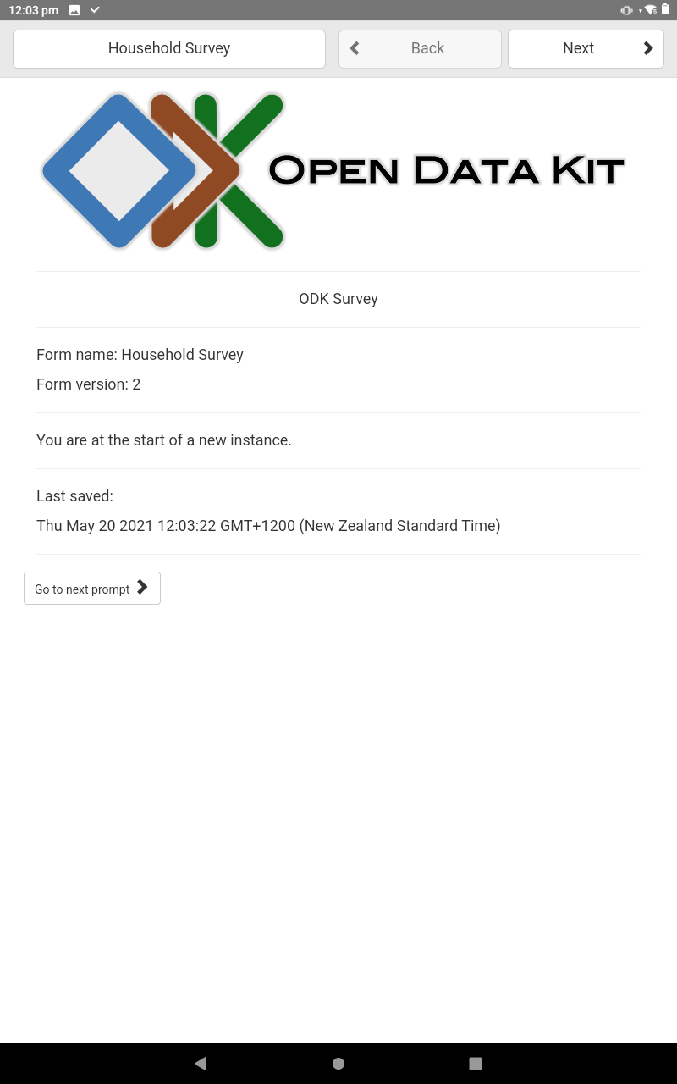

This next screen is just here to confirm your creation of a new instance.
Select ‘Go to next prompt’ or ‘Next’(at the top right on the screen)

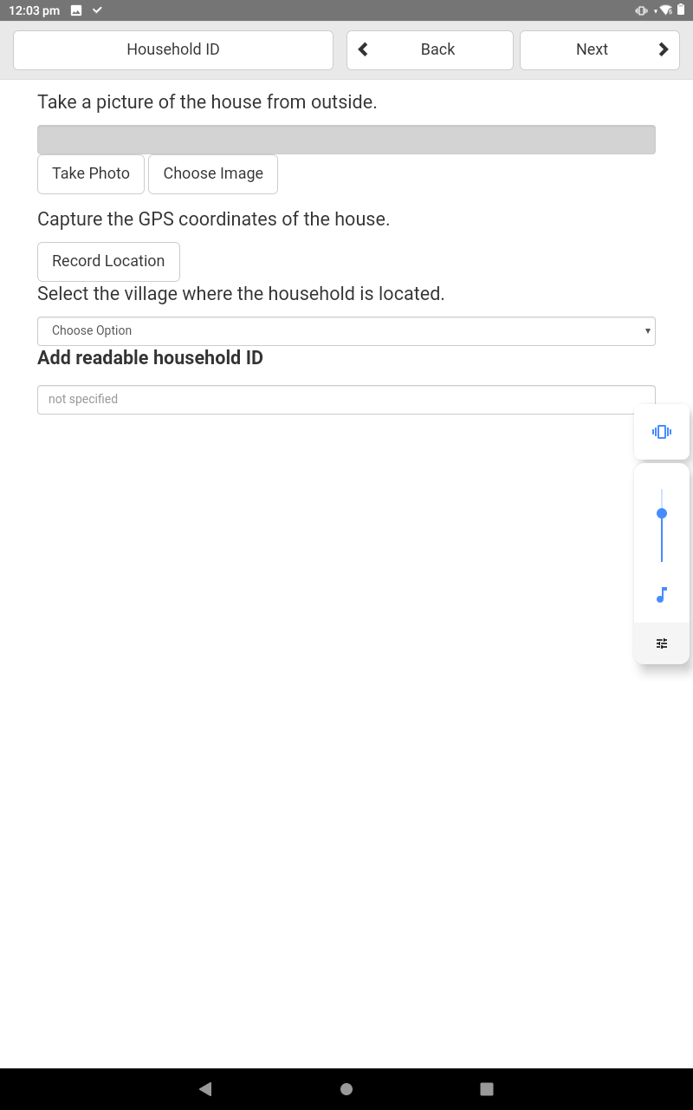

The information gathered here will help to identify the household for future data analysis.

For the GPS, please wait until the accuracy stabilises and presents you with a confirmation dialog.

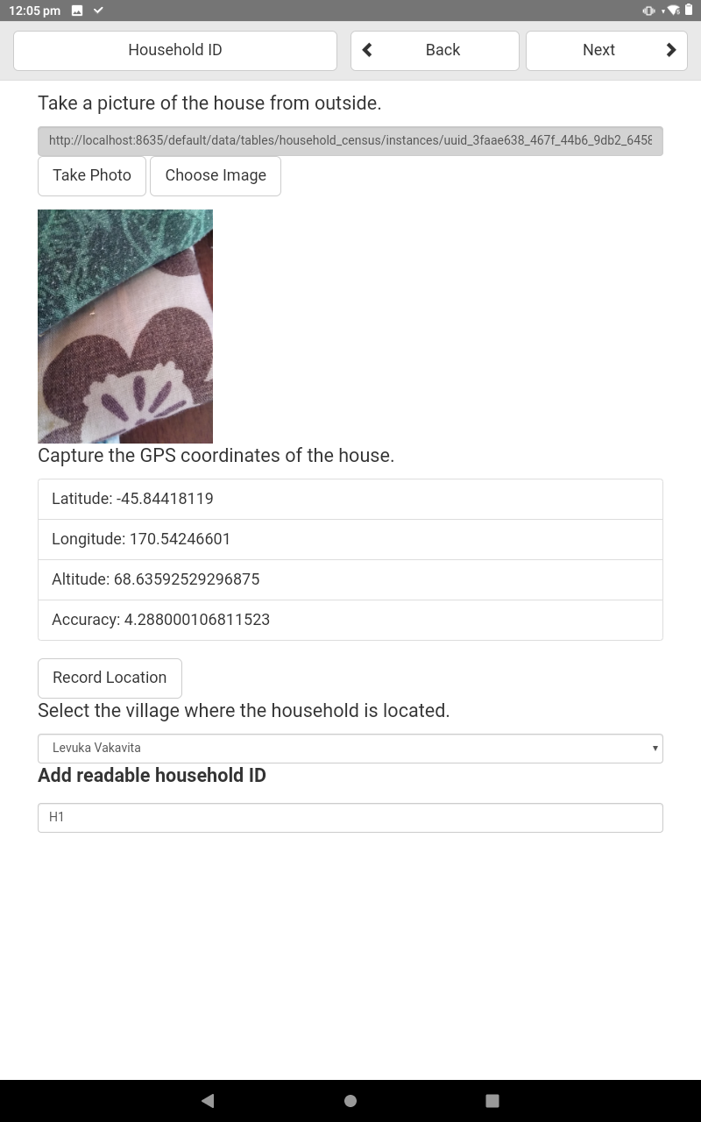
Ideally this step would be done before entering the house, as the GPS will have difficulty getting an accurate reading, and the picture of the house should be taken from outside.
The readable household ID could be the street address(if applicable) or another systematic way of helping to identify where the house is for the data collectors.

Example of screen once information has been entered.

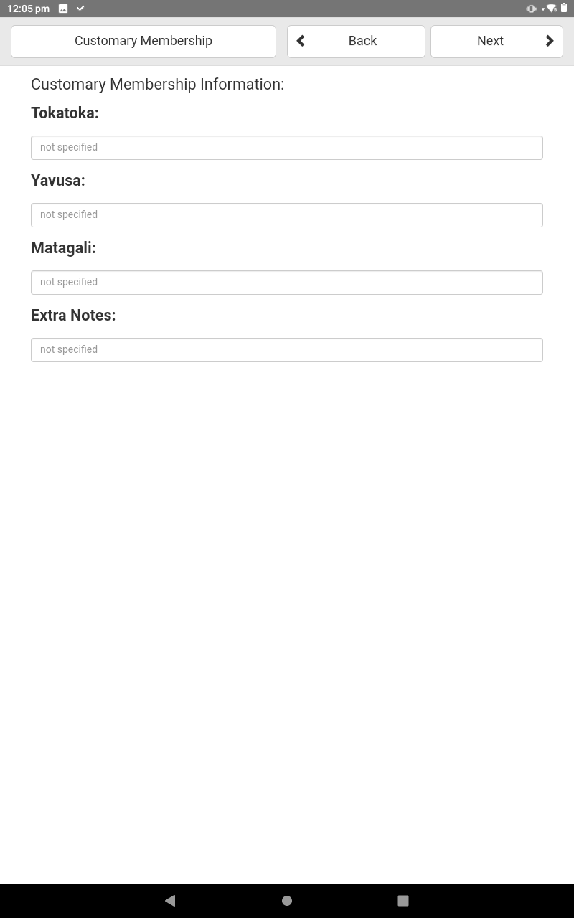
Enter the information pertaining to the households customary membership in the text fields.

Note: The ‘Extra Notes’ field has no character limit.

Household Members

The next screen is where we begin to get data on each member currently living in the household:
Like the Household screen, each person is an instance, and they will be listed here if they hold the same household_id variable as the household you are surveying.
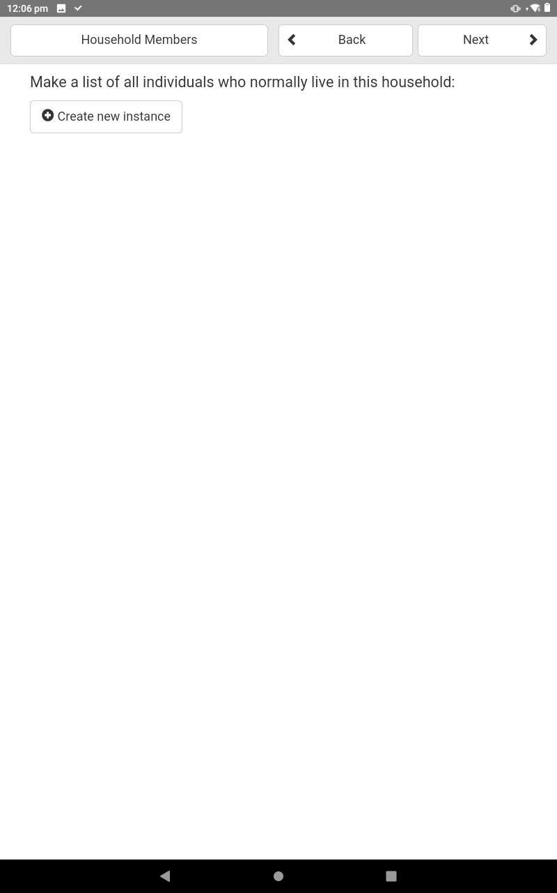

Begin by creating a new instance, starting with the head of the household, in our case Boss Ding.

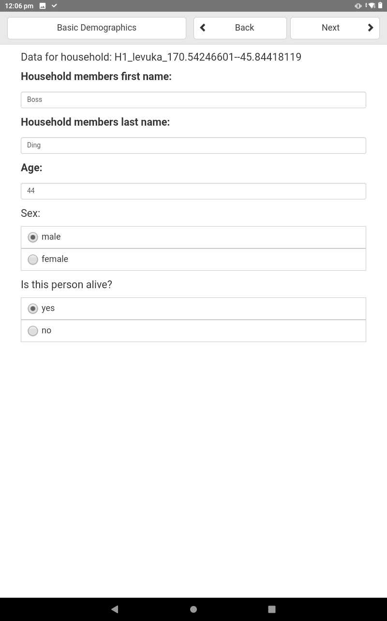

Update screenshot for extra fields

Using the data given in the example table, enter the data for Boss Ding as shown in the next few screens, selecting ‘Next’ in the top right corner when you are done entering the data requested.

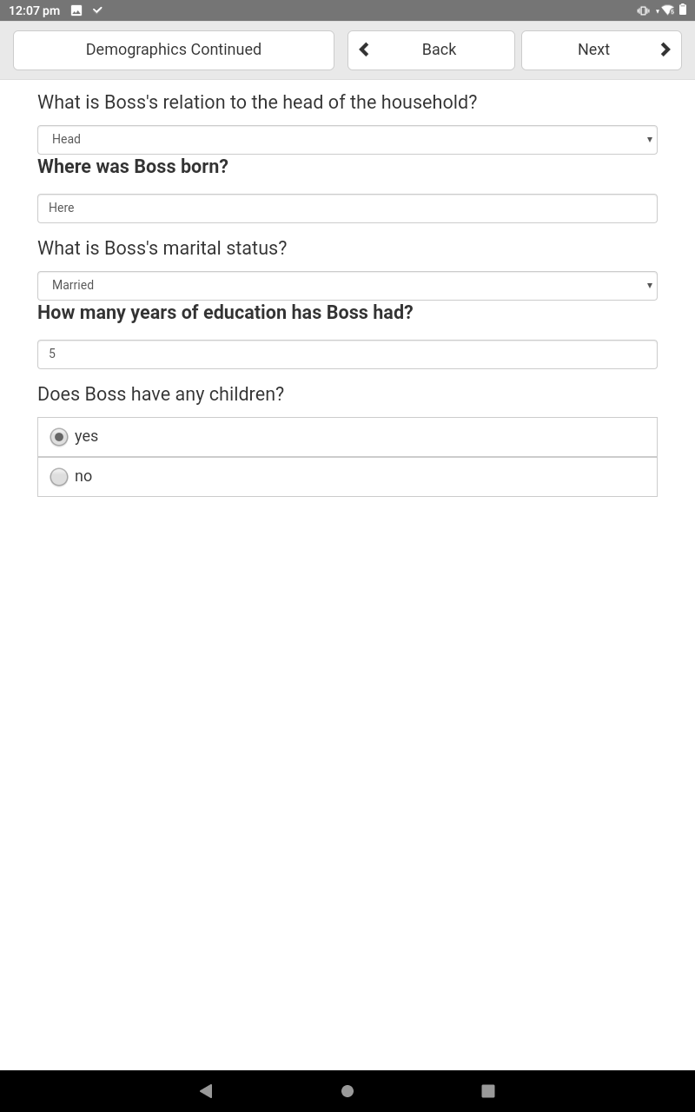
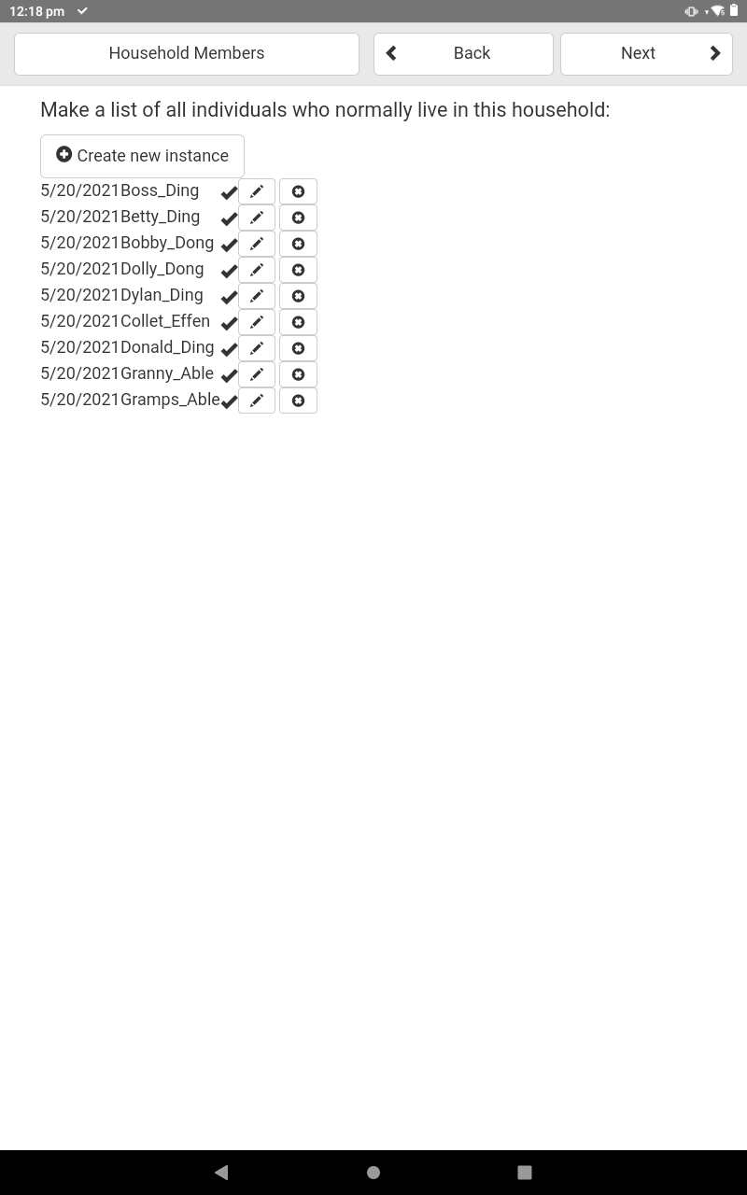
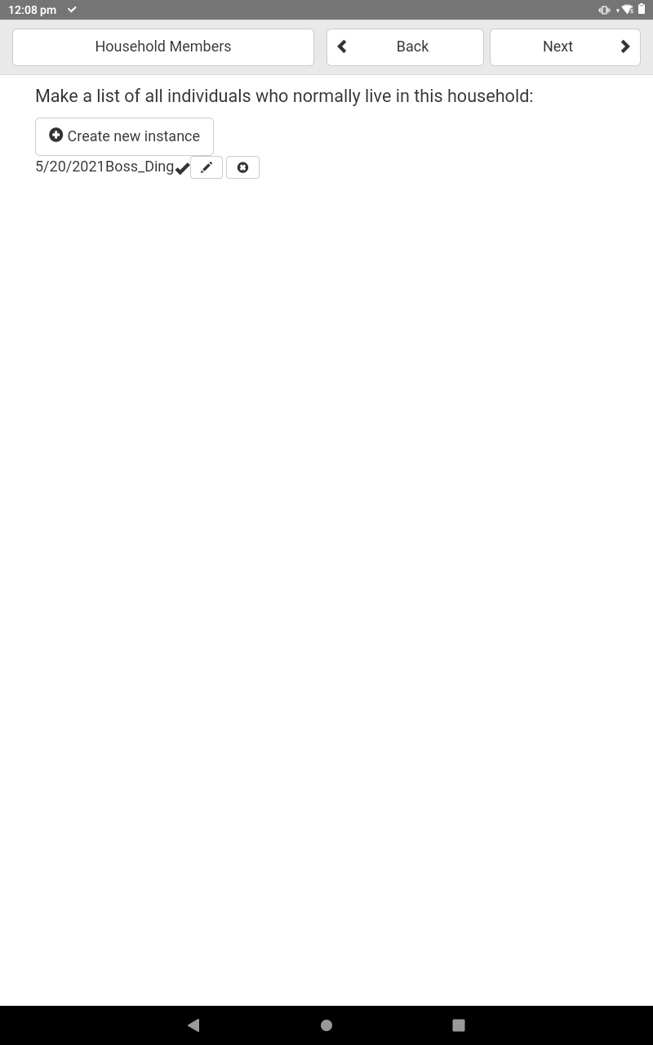
Note: When entering data into some fields, you will have to wait for a brief period before selecting the next field.

This pause is due to the program writing the information to the database.

You will find yourself extremely annoyed if you try quickly move onto the next field, as it will just as quickly send you back to the previous field.
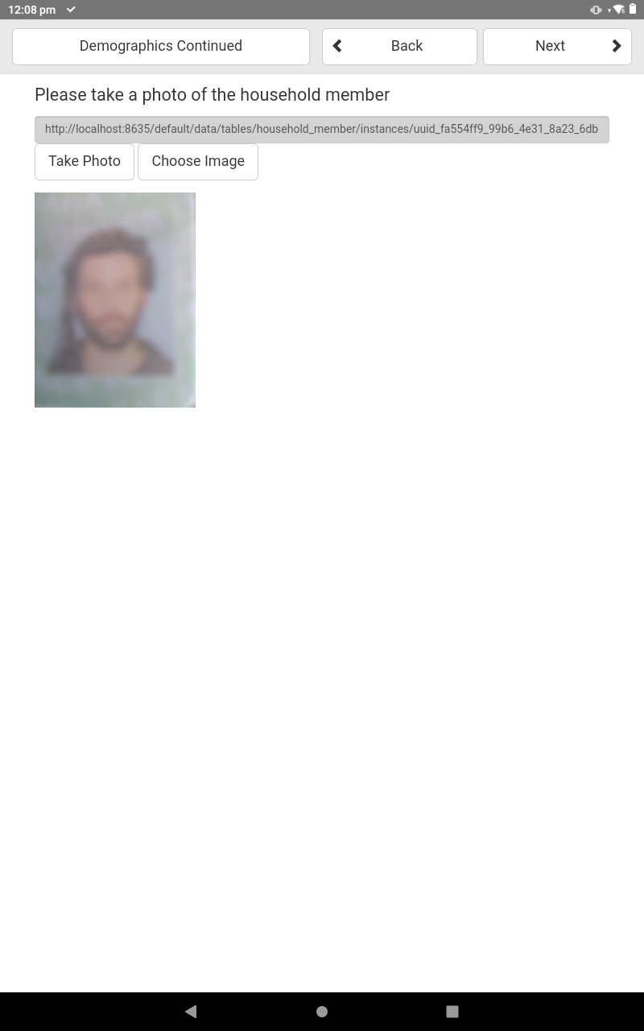

It is suggested that the resolution of your camera images be as low as possible while retaining enough detail for future identification purposed. This is so the server is not bogged with too much data, and the syncing process between server and devices is kept as short as possible.

Once you have entered the information for Boss Ding, you will see their instance shown on the Household Members screen which follows.

Continue on and enter the information for each of the people who live in the household in the example (those contained within the light blue shape in the tree, or having light blue numbers in the table)

Here is what you should see once all of the persons normally living in the household have been entered.

Marriages
In this section we will enter the relationships between people which have borne children, creating edges between the mother and father of all offspring directly related to the household members.
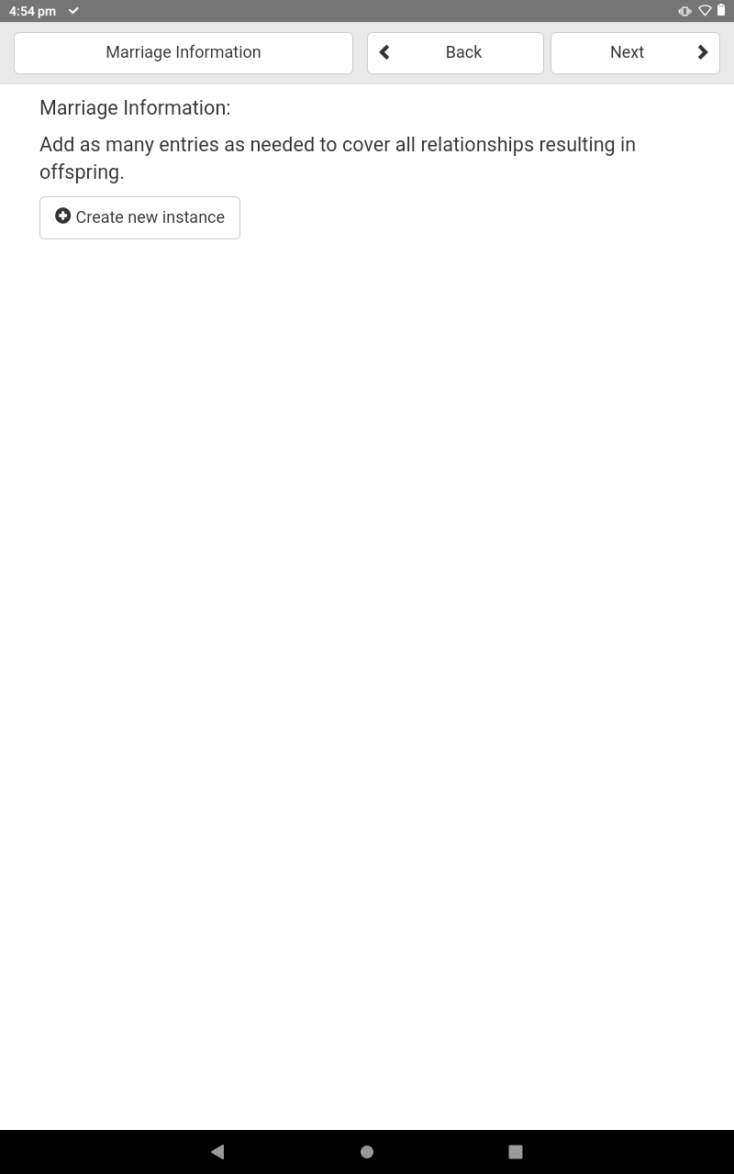

Once again, instances are created for each entry.

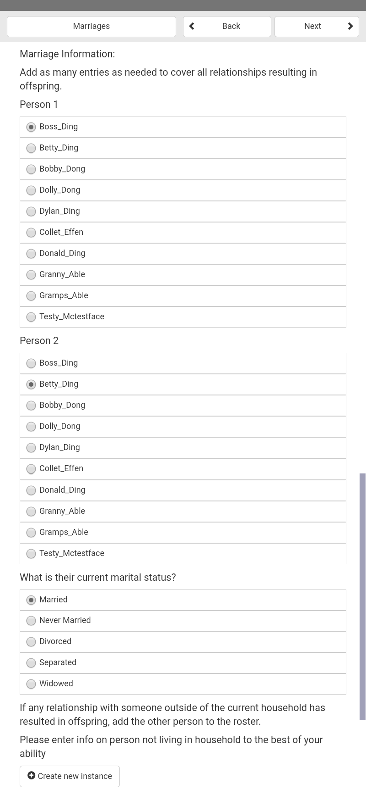

In this screen we are presented with every person entered in the household.

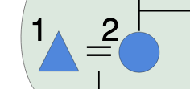

For the first entry, select Boss Ding as Person 1, and Betty Ding as Person 2, and set their marital status as Married.
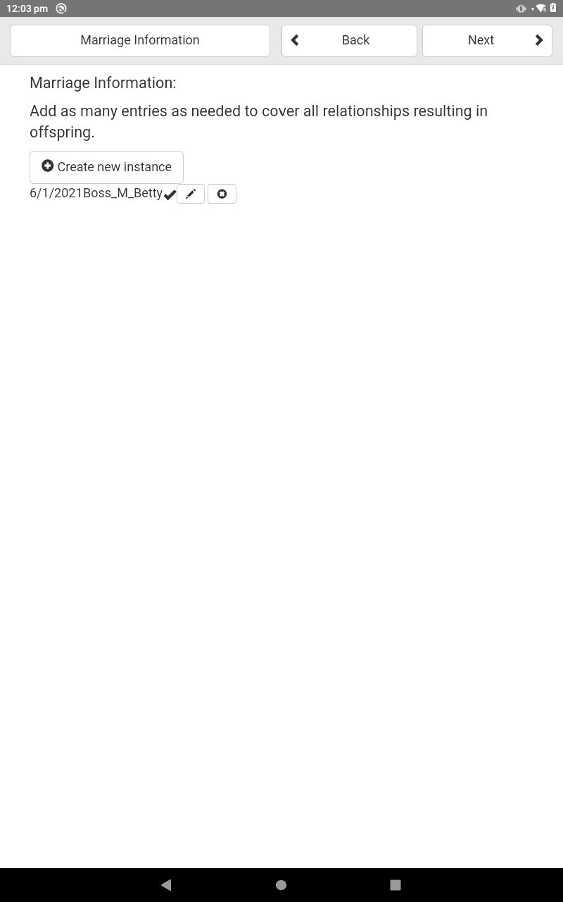
Once we have done this and clicked next, we will see that an instance has been created showing the first name of each person separated by a letter indicating their marital status:

M = Married, NM = Never Married,
D = Divorced, S = Separated,
W = Widowed

Continue to enter the data as shown on the example tree.

For the relationships involving persons outside of the household, such as that between Dolly Dong and Garry Effen, we will need to enter Garry’s information to the best of the knowledge of the interviewee.
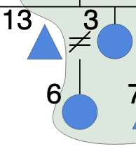

Dolly and Garry have a child together, but are divorced, with Garry not living in the household.

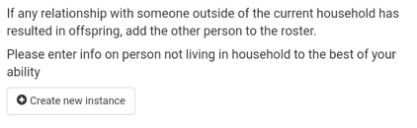
For this case, when we are in the Marriage Information Instance screen (shown above), we must select the option at the very bottom of the screen, Create new instance.

This will take you to the same form we used to enter each household members details with slight differences under the hood. Here we enter Garry’s details, and once we have completed this step, Garry will appear in the list of Person’s under the Marriage Information Instance screen.

Now we can select Dolly and Gary as Person 1 and Person 2, and assign the Divorced Marital Status.

Continue to enter the relationships as shown in the example household tree.
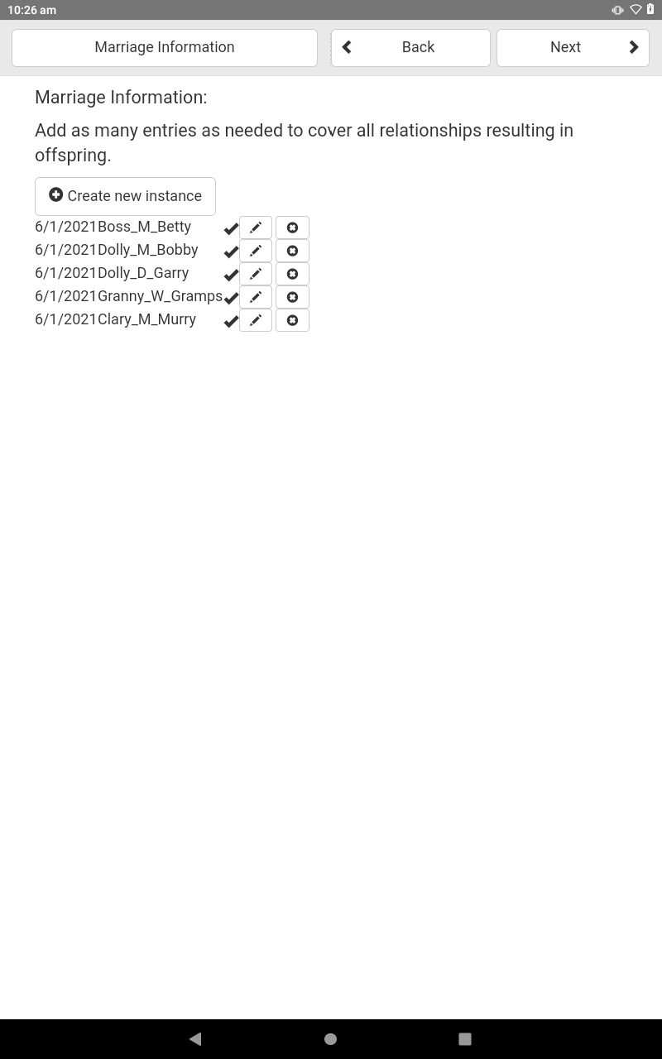

Above shows the completed instance list of relationships relating to our example household.

Family Information
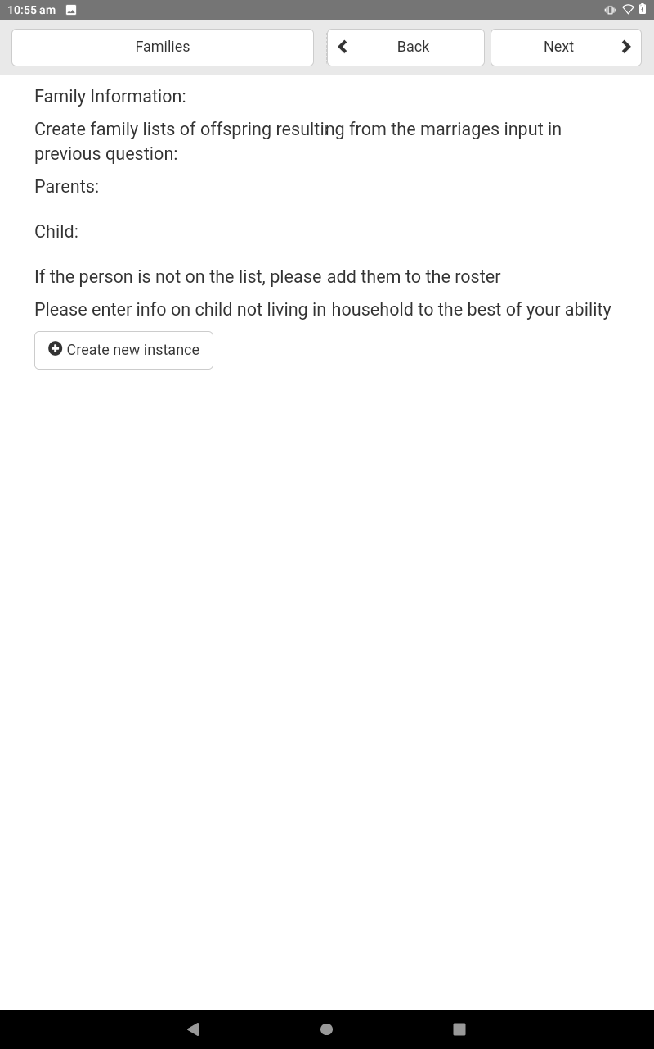
The next section creates links between the relationships entered in the marriage information to their offspring.

Initially there will be a screen much like the ones we have encountered before (shown on right) where we create a new instance of a family tie.

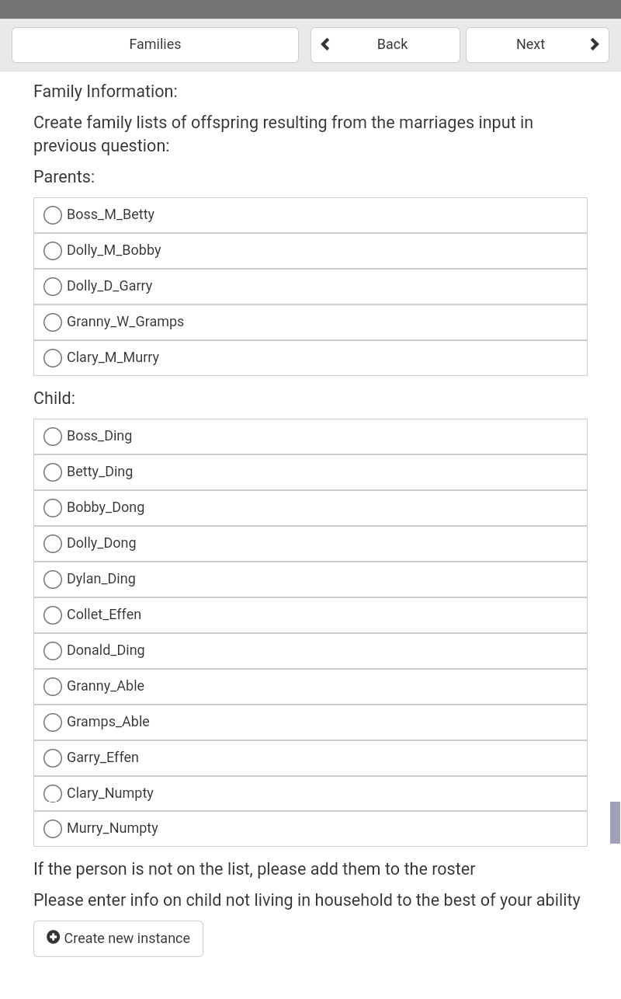

Using the example tree, select the appropriate parents and one of their children.

Note that we can only select one child at a time, therefore we have to create a new instance of a family for each child that a relationship bore.

Like the marriage information screen, if a child does not live in the household or is deceased, we have to create a new instance of this person. Once this is done, their name will be found under the child heading of the screen.

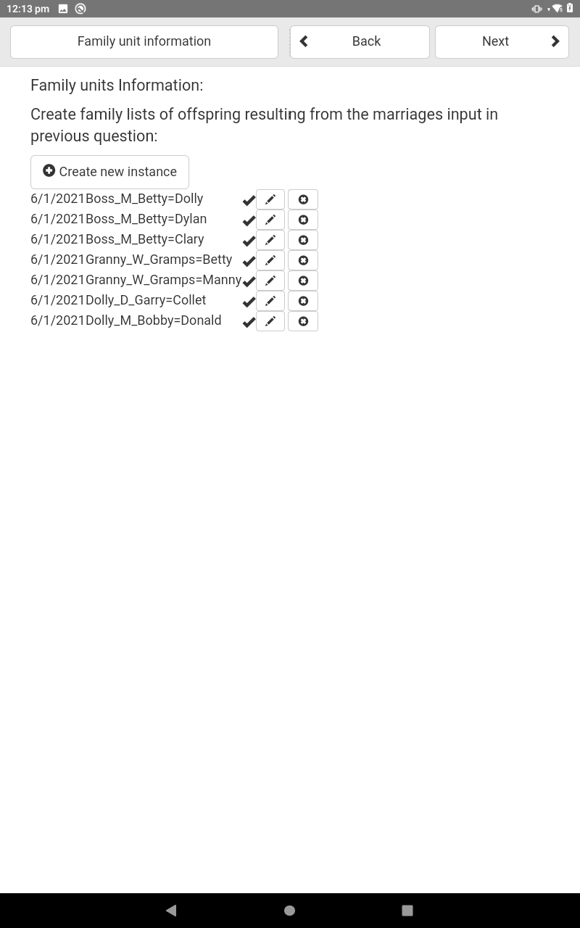

Here are the completed Family Units instances for the example tree.

Each instance is named with the marriage selected followed by an equals sign and the child’s first name.

Other Household Information

The last few screens are very self explanatory.
The Household Items screen will be populated by the results of the free listing survey before the main census is carried out.

